Salesforce Training Program 2026: Your 3-Month Roadmap to a Job-Ready Salesforce Career
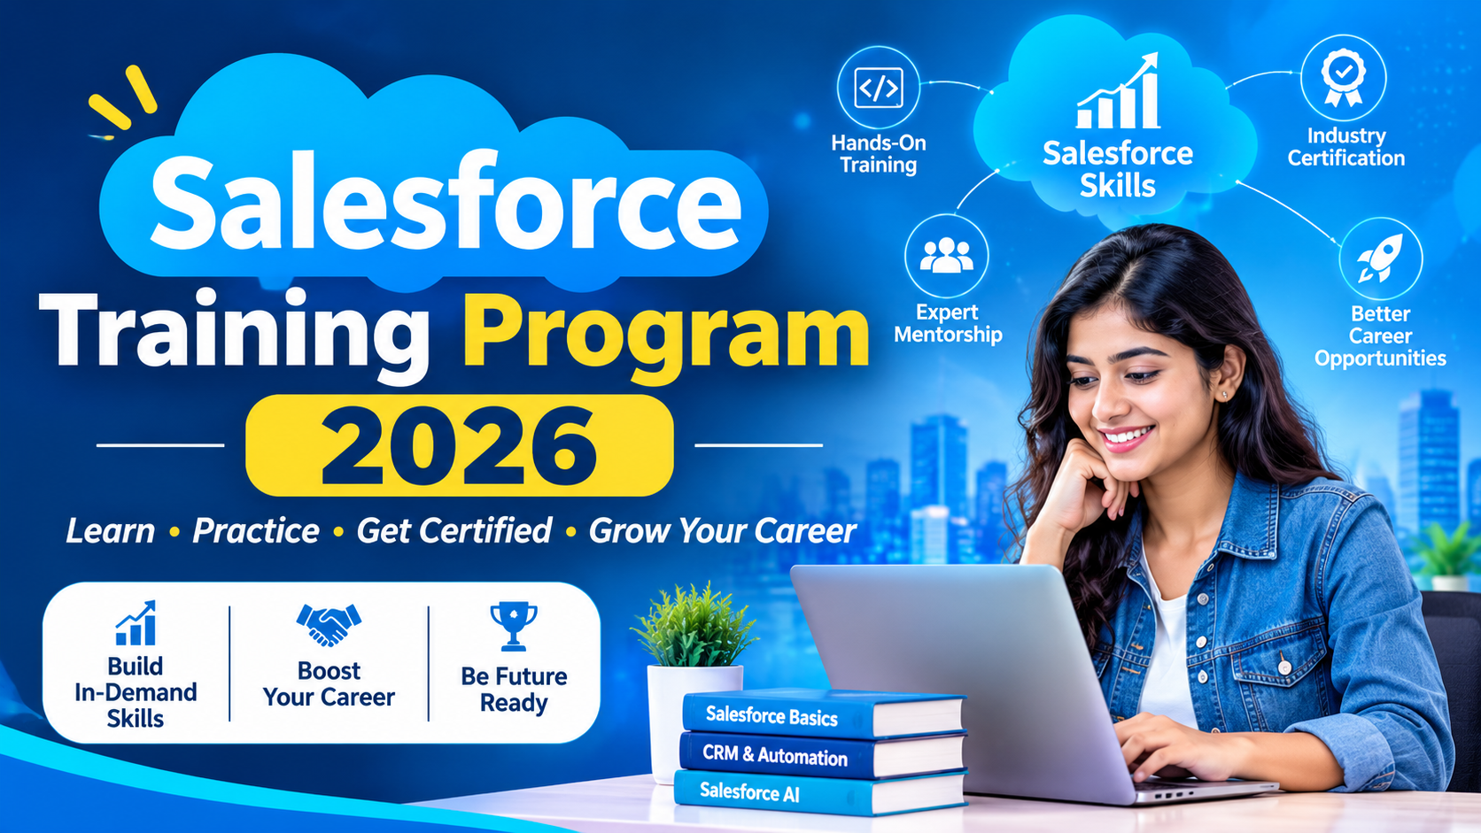
Meta description: Explore RevApex AI's Salesforce Training Program: live instructor-led classes, real projects, Apex, LWC, integrations, Agentforce and certification prep in 3 months.
Salesforce is no longer just a CRM. It is the platform where sales, service, marketing and data come together, and now where AI agents are starting to do real work. Companies of every size are hiring people who can configure it, extend it and connect it to the rest of the business.
The gap is skills. Many learners watch tutorials, collect badges and still freeze in interviews because they have never worked on a real org with real requirements. A strong Salesforce training program closes that gap by turning theory into practice. This guide explains what to look for, and how the RevApex AI Salesforce Training Program is built to get you job-ready in three months.

Why a Salesforce Career Is Worth Pursuing
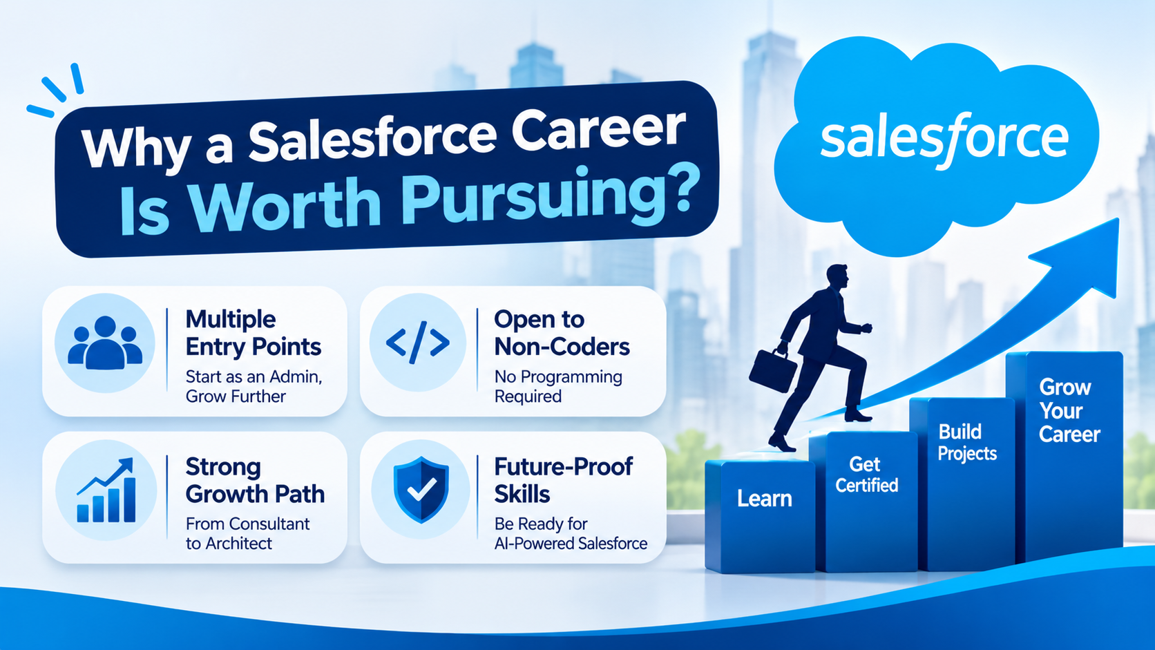
Salesforce sits at the centre of revenue operations for thousands of organisations. Every one of them needs admins to keep the platform healthy, developers to build custom logic, and integration specialists to connect it with ERPs, marketing tools and data warehouses.
That demand creates real advantages for newcomers:
- Multiple entry points. You can start as an Admin, grow into a Developer, or specialise in Integration or AI.
- Open to non-coders. Admin work is largely declarative, so career switchers from non-IT backgrounds can begin without programming.
- Strong growth path. Certifications and project experience lead to consultant and architect roles.
- Future-proof skills. With Einstein and Agentforce, Salesforce professionals who understand AI are moving to the front of the hiring queue.
The platform rewards people who combine business understanding with technical skill, and that is exactly what good training should build.

What a Good Salesforce Training Program Must Include
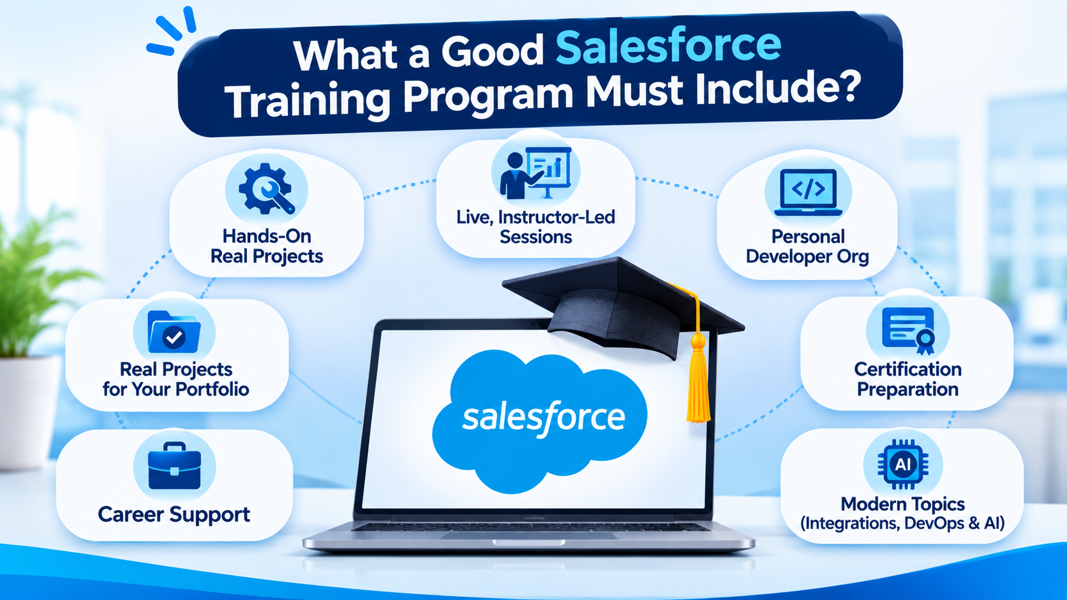
Before enrolling anywhere, check that the program covers more than slides and quizzes. Look for these essentials:
- Live, instructor-led sessions so you can ask questions and get feedback in the moment.
- Practising trainers who work on real projects and can explain why something is done a certain way, not just how.
- A personal developer org from day one, so every concept is tried hands-on.
- Real projects that you can discuss in interviews and show in a portfolio.
- Certification preparation with practice exams and exam strategy.
- Career support: resume reviews, mock interviews and guidance on applications.
- Modern topics, including integrations, DevOps and AI, not just the basics.
A program that ticks all seven gives you skills and proof of skills, which is what employers actually evaluate.

Inside the RevApex AI Salesforce Training Program
RevApex AI's program runs for three months across 12 structured modules of live, instructor-led sessions. It starts from zero, so no prior Salesforce experience is needed, and moves step by step towards real project work.

Foundations and Security
You begin with CRM concepts, the Salesforce ecosystem, objects, fields, formulas, validation rules, page layouts and record types. Next comes the security model: org-wide defaults, role hierarchy, sharing rules, profiles, permission sets and field-level security. These topics appear in almost every Admin interview, so they get proper depth.

Automation with Flow
Modern Salesforce automation runs on Flow. You work with record-triggered, scheduled and screen flows, approval processes, debugging and error handling, and learn how to migrate legacy Process Builder automation. A live lead-routing project turns the theory into something you can demonstrate.

Apex, LWC and the Developer Track
For those aiming at development, the program covers Apex classes, collections, SOQL, SOSL, DML, bulk-safe triggers and asynchronous Apex such as Batch and Queueable. You also learn to write test classes, build Lightning Web Components, and use Salesforce DX, Git and CI/CD pipelines. This is the toolkit hiring managers expect from a Platform Developer.

Integration Architecture
Real businesses rarely run on Salesforce alone. The integration modules teach REST and SOAP APIs, Bulk API 2.0, Connected Apps, OAuth 2.0, named credentials, Platform Events and Change Data Capture, plus MuleSoft fundamentals and API testing with Postman. You finish with an ERP-to-Salesforce integration project, one of the most impressive items you can bring to an interview.

Einstein AI, Agentforce and Data Cloud
The final modules cover Einstein Prediction Builder, prompt templates, Agentforce agent configuration, Data Cloud basics and Next Best Action. AI skills are still rare among entry-level candidates, so this section can set you apart.

Learning by Building: Projects That Matter
The biggest difference between knowing Salesforce and working in Salesforce is project experience. In the RevApex program you build on real, enterprise-style orgs, including lead-routing automation, an ERP-to-Salesforce integration and a full-stack capstone.
Every learner gets a dedicated developer org from day one, along with tools such as Workbench and VS Code with Salesforce extensions. By the end you will have a portfolio of working solutions and the confidence to explain your design decisions, which is exactly what interviewers probe.

Certification Support
Salesforce certifications validate your skills and help your resume pass screening. The program prepares you for the Administrator (ADM-201) and Platform Developer I and II exams, as well as AI credentials, with practice questions, timed mock exams and exam-day strategy sessions.
Exam vouchers are not included in the course fee, but students receive discounted voucher access through the program's partnership, along with a prep bundle and a pre-exam coaching session.

Career Support Beyond the Classroom
Skills only help if they reach the right employers. Alongside technical modules, RevApex AI includes mock interviews with hiring managers, resume and LinkedIn profile reviews, and placement support through its hiring network. Learners also join an alumni community where referrals and job leads are shared.
This blend of training and career guidance is what turns a course into an actual career move.

Flexible Formats for Busy Learners
The standard batch runs for three months on weekdays or weekends, with a six-week fast-track option for experienced IT professionals. Live sessions are recorded, so a missed class never means a missed concept. You can attend live online or, where available, in person.

Who Should Enrol?
The program suits:
- Freshers from any graduation stream who want a structured entry into IT.
- Career switchers from non-IT backgrounds, such as business analysts, who want a technology role.
- Working IT professionals, including Java and other developers, moving into the Salesforce ecosystem.
- Existing admins who want to add development, integration or AI skills.
If you are curious, willing to practise and ready to commit a few focused months, you have what it takes.

How to Get the Most from Your Training
A few habits make a big difference:
- Practice daily. Even 45 minutes in your developer org beats a weekend binge.
- Build beyond the assignments. Create a small app for a problem you know well.
- Document your projects. Write short summaries of what you built and why.
- Start certification prep early. Do not wait until the course ends.
- Use mock interviews. Treat them as seriously as the real thing.

Start Your Salesforce Journey Today
Salesforce rewards people who can build, connect and automate. With a curriculum that spans Admin, Development, Integration and AI, hands-on projects, certification prep and career support, the RevApex AI Salesforce Training Program gives you a clear route from beginner to job-ready professional in three months.

